

Splitting Course Sections

Visit the GatorEvals central portal via - https://my-ufl.bluera.com

Please review the Use Cases for Splitting a Class Number on the GatorEvals website before splitting to learn about typical use cases where splitting could occur and when not to split.

Course sections/Class Numbers can be split into multiple sub-sections for evaluation purposes between different instructors and teaching assistants.

For you to split courses, you may click the current term “Main DIG Project...” under “My Active Tasks”

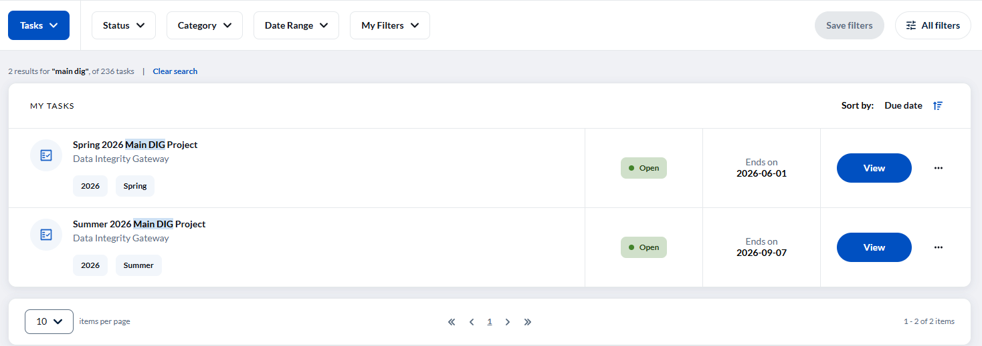
OR you can type “Main DIG Project” in the upper search bar of the page.

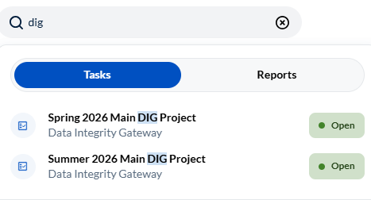

On the new page, locate the course section you want to split.
Choose the course section you’d like to split and click on the three dots button, and then select “Split”.

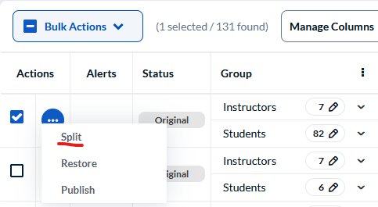

Enter the number of sub-sections the course section should be split into and then click “Yes, I’m Sure”.
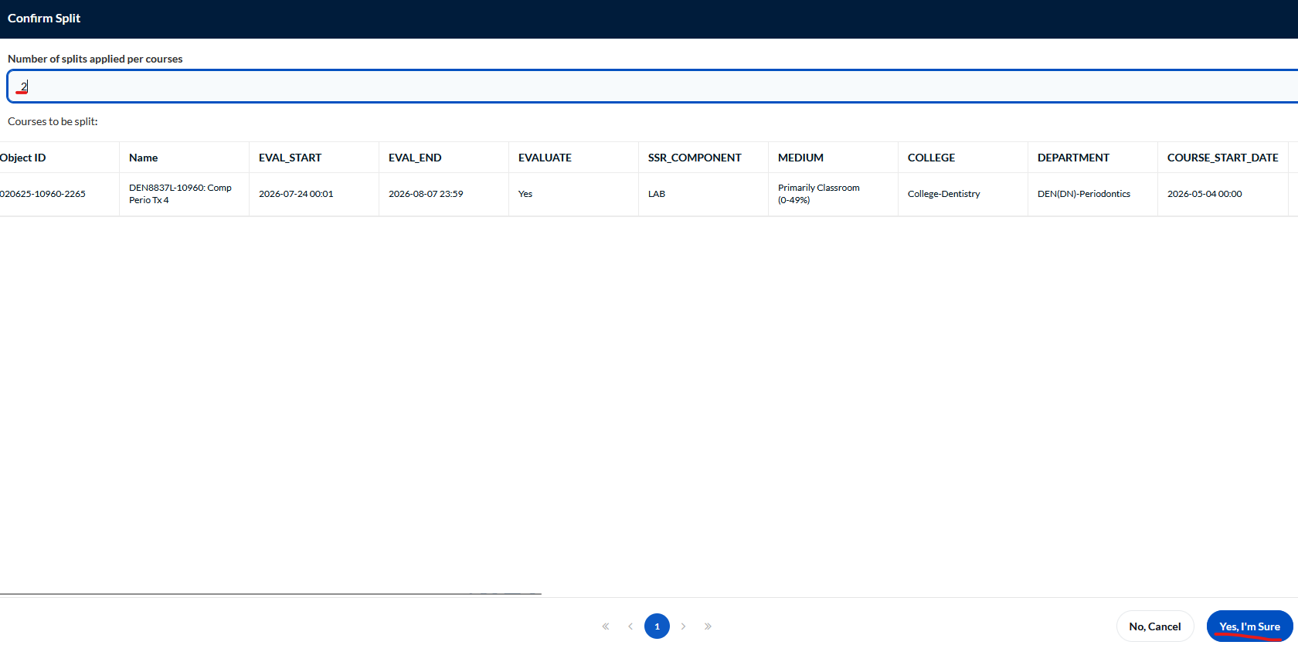

Once the split is complete a new code will be shown (an S alongside the number of splits).

In case you found that you made a wrong split. You can click on the three dots beside the course section and select “Unsplit”. Then select “Yes, I’m Sure”.
You can also click on the three dots and select “Restore” to bring the course back to the original.

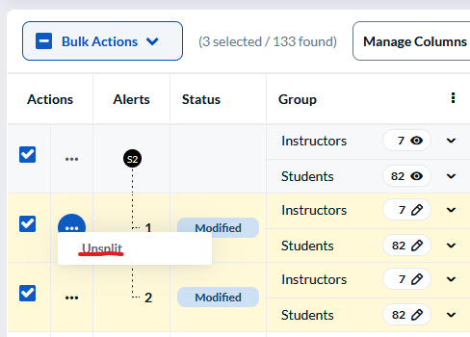

The original course sections' details are kept for comparison purposes, alongside rows for each of the new sub-sections.

Split 1 shows the primary instructor who gets the standard evaluation and Split 2 shows the TA or GA who gets the UNV-LEC form.

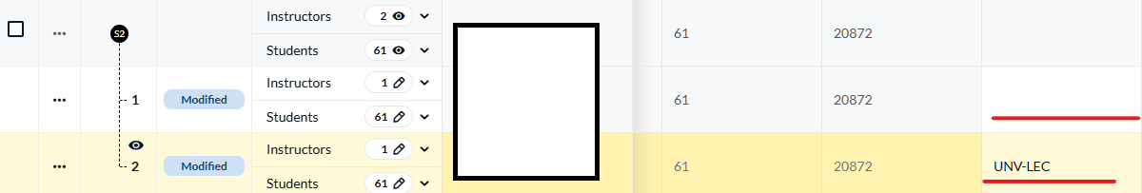

Assigning Instructors

- You can now review instructors at a glance by clicking the three dots in “Group”, then “Expand Instructor”

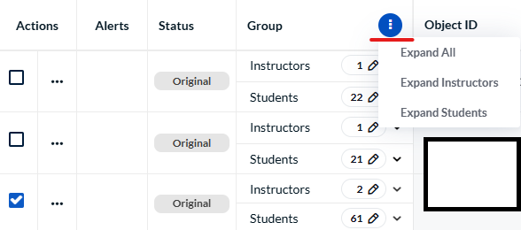

- Click the pencil icon beside Instructor to remove an instructor from each split before publishing the course.

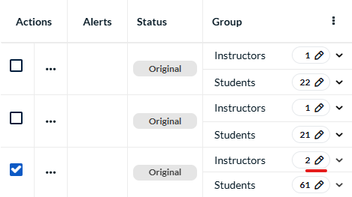

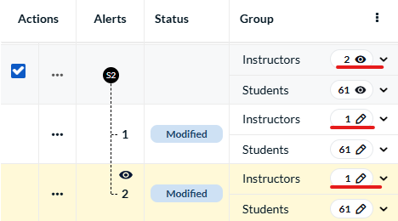

- If the instructor(s) listed is incorrect or you want to remove an instructor after splitting, check the box in their row and then select the Remove button at the bottom left of the Instructor screen.

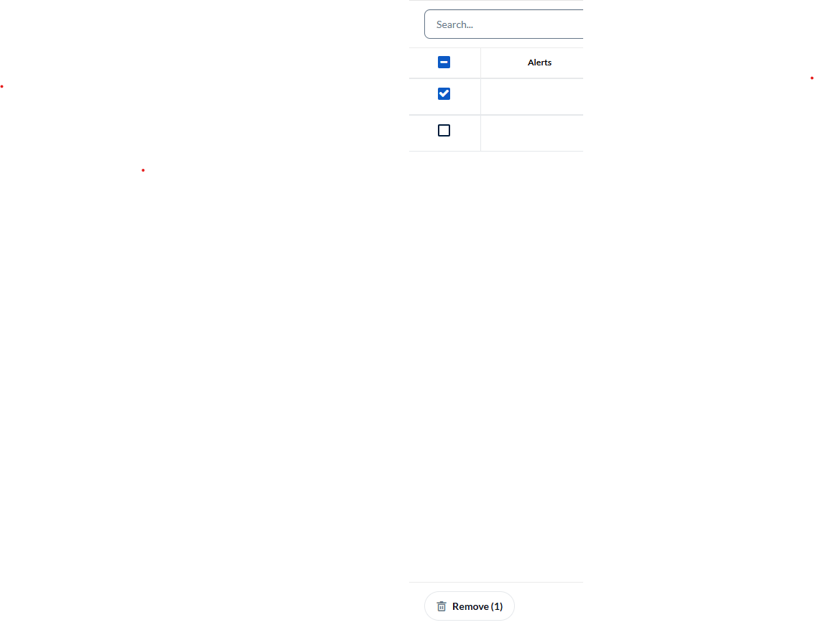

- To add an instructor, click “Assign Instructor” in the upper right. Search for the correct / new instructor and click the blue Assign button at the bottom right to add them to the course.
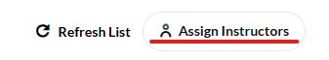

Review each row for the course fields and update all details to what should be in the finalized evaluation data (evaluation dates, course start & end dates, associated instructors etc.).

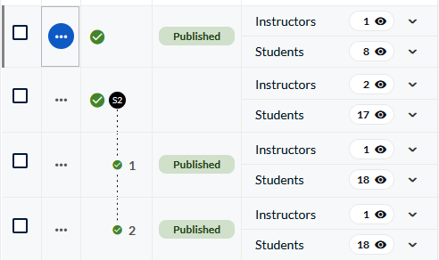

When you scroll to the far right, you will see the course start and end dates.

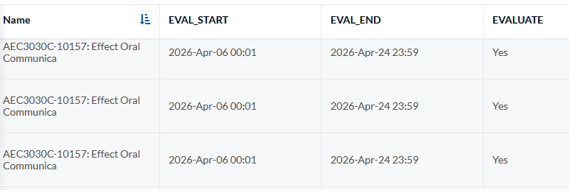

To finalize, click on the three dots and select “Publish”. This will send the updated sections to the finalized course evaluation data where this will appear as 2 individual course sections.

