

Merging Course Sections

Visit the GatorEvals central portal via - https://my-ufl.bluera.com

A few things to note about merging courses:

The following points will help you to know why you should merge, what not to merge, and how to view merged courses.

- Merging takes multiple courses and treats them as one course.
- Don’t publish a course that has one student, but you can merge it with a higher enrollment class number (same course taught by the same instructor).
  - For example, MAN7935-12345 and MAN7935-67891 taught by John Smith can be merged. But an incorrect merge would be MAN7935 and MAR6635 taught by John Smith. So, if the course names do NOT match, even with the same instructor, they should NOT be merged.
- Only merge courses with low number of students taught by same instructor/course (e.g., a section with 1 student can be merged with a section of 4 students, or a section of 3 students with a section of 10 students).
  - You should NOT merge sections where both enrollment counts are above 5.
- You don’t need to merge courses to let instructors get a combined result. The system automatically aggregates it for you.
- To view response rates for merged courses, you can view the “Response Rate Export Report”.

To merge two or more course class numbers into a single record, you may click on the current term “Main DIG Project...” under “My Active Tasks”

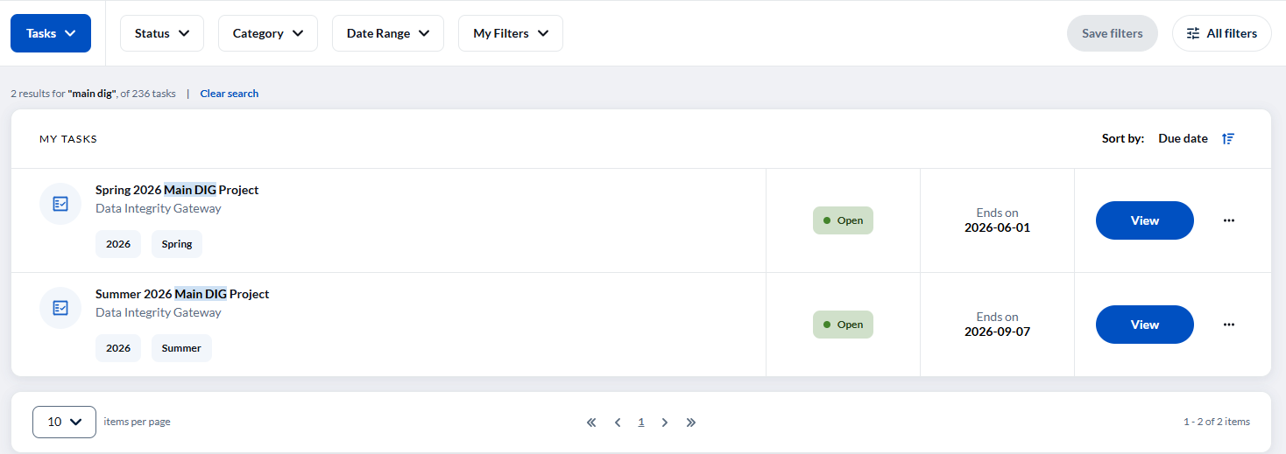

OR you can type in “Main DIG Project” in the upper search bar of the page.

On the new page, locate the same course with high and low enrollment of students taught by the same instructor.

Search for the sections you wish to merge together and then select them with the checkboxes on the left.

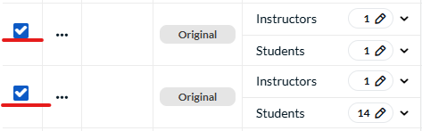

Click the “Bulk Actions” button, and then select “Merge courses”

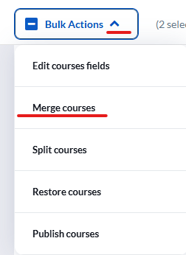

A confirmation screen will pop up. Verify that the correct courses are listed and then click “Yes, I’m Sure” to finalize.

Beside the records you will see a new code representing the newly merged course. The letter M stands for merge while the number 2 beside M represents the number of course sections that were merged. That is, two courses that were merged will display M2.

You can view the new course’s details by scrolling to the far right of the merged course row.

Click on the new code to see or expand the merged rows. You may click on the icon to hide/display original courses for a merged course.

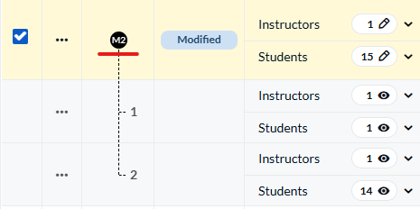

The details of the merged course will be shown, along with rows retaining the details of the original courses. Update any necessary fields (Medium, Eval start- and end-dates etc.) and select “Save row”.

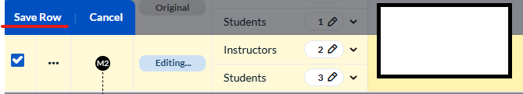

In case you receive this alert signal after merging (Invalid). This indicates that the course cannot be published because one or more required fields are missing or invalid.

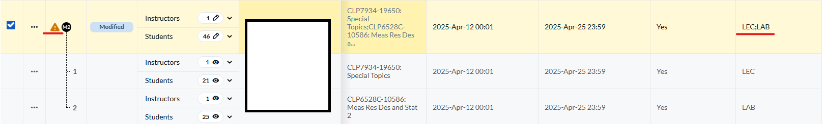

From the screenshot above, the merged course showed the invalid alert signal. This means that the merged course cannot be published because two different courses were selected and the SSR_COMPONENT showed both LEC; LAB.

To fix problem like the above:
- Only merge courses with the low number of students taught by the same instructor and same course.
- Select either LEC or LAB depending on the mode of instruction for the section with high enrollment of students.

In case you merged wrongly and want it corrected (un-merged), you can click on the three dots icon next to one of the merged course sections to unmerge OR click the black M# button to expand the tree. Locate the row for the course that should be unmerged, click the 3 dot icon under the “Actions” bar, and select un-merge.

Please note that a course that has been merged but not yet published can be unmerged into it's individual course section, but only as long as it has not been published.

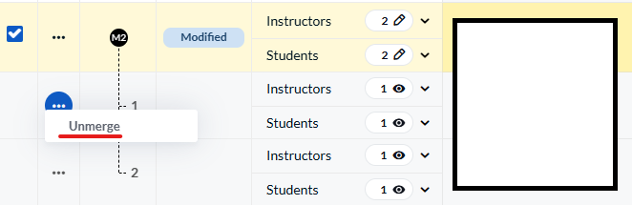

You will get a confirmation screen like before. Select “Yes, I’m Sure”.

You can then restore the modified course to its original state by selecting “Restore” from the three dots icon.

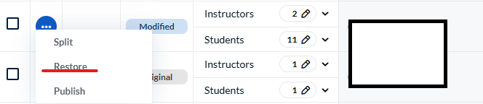

When merged courses are published, they cannot be restored. So, if there’s any error that needs to be corrected after the merged courses are published, you will need to contact us at gatorevals-support@ufl.edu

